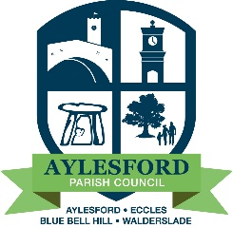
Aylesford Parish Council
23 Forstal Road, Aylesford, Kent, ME20 7AU
Tel: 01622 717084 Email: mel@aylesfordparishcouncil.org.uk
www.aylesfordparishcouncil.org.uk

To All Members of the Policy and Resources Committee

Agenda for the Meeting of the Policy & Resources Committee to be held on Tuesday 4 April 2023 at the Aylesford Parish Council Office, Aylesford commencing at 7.35pm or at the conclusion of the Planning Committee whichever is the later.

AGENDA

1. Apologies

2. Declarations of Interests

3. Minutes of the last meeting held on 7 March 2023

4. Accounts for Payment

The Payment Schedule is attached to the agenda.

5. Finance Advisory Sub Committee

To receive the minutes of the meeting held on 21 February 2023 and consider any recommendations within.
Note: There was no meeting on the 21 March 2023, due to there being no business.

6. Law and Order

6.1 Police Report – No report received since the last meeting of this committee.

7. KALC

8. TMBC/Parish Partnership Panel Meeting

9. Council Vacancies

No Vacancies To Note

10. Public Convenience Review – Aylesford Toilet

No further update received Ongoing

11. Adoption of Aylesford Station

Councillor Shelley to report on progress To Note

12. Kings Coronation Plaque for Coronation Gardens, Aylesford

Different options including designs are being researched. Ongoing

13. Additional meeting of Full Council

To agree an additional meeting be scheduled of Full Council on 13th June 2023 to approve the Annual Governance Statement and Accounting Statements for submission to the External Auditor, Mazars LLP. The extra meeting is required in order to comply with the deadline submission date for the Statements of the 30th June 2023.

14. Any Other Correspondence

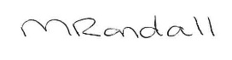

Melanie Randall
Clerk & Responsible Financial Officer Date: 30 March 2023

